DS_Final_Prediction_Models_CHB.R
bushc
2026-04-26
library(dplyr)
## Warning: package 'dplyr' was built under R version 4.4.3
##
## Attaching package: 'dplyr'
## The following objects are masked from 'package:stats':
##
## filter, lag
## The following objects are masked from 'package:base':
##
## intersect, setdiff, setequal, union
library(ggplot2)
## Warning: package 'ggplot2' was built under R version 4.4.3
library(tidyverse)
## Warning: package 'tidyverse' was built under R version 4.4.3
## Warning: package 'tibble' was built under R version 4.4.3
## Warning: package 'tidyr' was built under R version 4.4.3
## Warning: package 'readr' was built under R version 4.4.3
## Warning: package 'purrr' was built under R version 4.4.3
## Warning: package 'stringr' was built under R version 4.4.3
## Warning: package 'forcats' was built under R version 4.4.3
## Warning: package 'lubridate' was built under R version 4.4.3
## ── Attaching core tidyverse packages ──────────────────────── tidyverse 2.0.0 ──
## ✔ forcats 1.0.1 ✔ stringr 1.6.0
## ✔ lubridate 1.9.5 ✔ tibble 3.3.1
## ✔ purrr 1.2.1 ✔ tidyr 1.3.2
## ✔ readr 2.1.6
## ── Conflicts ────────────────────────────────────────── tidyverse_conflicts() ──
## ✖ dplyr::filter() masks stats::filter()
## ✖ dplyr::lag() masks stats::lag()
## ℹ Use the conflicted package (<http://conflicted.r-lib.org/>) to force all conflicts to become errors
library(lubridate)
# Reading in the main dataset
main <- read.csv(file="C:\\Users\\bushc\\Desktop\\DS-450\\2017_18 telemetry lock and dam 19 analysis master.csv",header=TRUE, sep=",")
## CONVERTING DATE COLUMNS
# Converting Date and Time
main$Date<-mdy(main$Date) # Convert Date column to Date objects
main$DeployDate<-mdy(main$DeployDate) # Fixed previous wrong format
main$Up2017.date<-mdy(main$Up2017.date)
main$Up2018.date<-mdy(main$Up2018.date)
main$START_DATETIME<-mdy_hm(main$START_DATETIME) # Convert Start datetime
main$END_DATETIME<-mdy_hm(main$END_DATETIME) # Convert End datetime
## CHECKING FOR MISSING DATA
# Columns to check for missing values
cols_to_check<-c("TRANSMITTERID", "Species", "AGENCY", "Deploy.loc",
"Up.passage", "Down.passage", "RESIDENCEEVENT",
"DURATION.sec", "DURATION.min", "log.DUR.min", "NUMRECS")
# Removing rows with missing values in key columns
main_clean<-main[complete.cases(main[, cols_to_check]), ]
# Count rows removed due to missing data
n_removed<-nrow(main)-nrow(main_clean)
cat("Rows removed due to missing data:", n_removed, "\n")
## Rows removed due to missing data: 119
## REMOVING DUPLICATES AND UNNEEDED COLUMNS
# Removing Duplicate Measurement Columns
main_clean<-main_clean %>% select(-Stage.Ft, -DURATION.sec)
# Removing Variables With 95% Missing
main_clean<-main_clean %>% select(-Up2017.date, -Up2018.date)
## CONVERTING CATEGORICAL VARIABLES
# Converting categorical variables to factors for easier modeling
main_clean$Season<-as.factor(main_clean$Season)
main_clean$Species<-as.factor(main_clean$Species)
main_clean$AGENCY<-as.factor(main_clean$AGENCY)
main_clean$Deploy.loc<-as.factor(main_clean$Deploy.loc)
main_clean$Up.passage<-as.factor(main_clean$Up.passage)
main_clean$Down.passage<-as.factor(main_clean$Down.passage)
main_clean$UpPass.2017<-as.factor(main_clean$UpPass.2017)
main_clean$UpPass.2018<-as.factor(main_clean$UpPass.2018)
## HANDLING MISSING VALUES
# Handling missing values for Length and Weight using median imputation
main_clean$Length[is.na(main_clean$Length)]<-median(main_clean$Length, na.rm=TRUE)
main_clean$Weight[is.na(main_clean$Weight)]<-median(main_clean$Weight, na.rm=TRUE)
## CREATING LOG-TRANSFORMED VARIABLES BECAUSE OF MAJOR OUTLIERS
# Add log-transformed versions of numeric columns
main_clean$log_DURATION<-log(main_clean$DURATION.min + 1) # +1 avoids log(0)
main_clean$log_NUMRECS<-log(main_clean$NUMRECS + 1)
main_clean$log_Weight<-log(main_clean$Weight + 1)
## CHECKING THE CLEANED DATA
summary(main_clean)
## Date Week Season Temp
## Min. :2017-03-16 Min. : 1.00 FAL : 620 Min. :-2.18
## 1st Qu.:2017-11-06 1st Qu.:12.00 SPR : 458 1st Qu.: 0.97
## Median :2018-01-19 Median :30.00 SUM : 830 Median :10.07
## Mean :2018-01-23 Mean :27.37 WINT:1016 Mean :12.47
## 3rd Qu.:2018-05-30 3rd Qu.:42.00 3rd Qu.:24.97
## Max. :2018-11-28 Max. :52.00 Max. :29.00
##
## Stage.m D.lock.n U.lock.n Tot.lock.n
## Min. :0.7132 Min. : 0.000 Min. : 0.000 Min. : 0.000
## 1st Qu.:1.1796 1st Qu.: 0.000 1st Qu.: 0.000 1st Qu.: 0.000
## Median :1.5362 Median : 3.000 Median : 3.000 Median : 7.000
## Mean :2.0752 Mean : 3.396 Mean : 2.935 Mean : 6.331
## 3rd Qu.:2.6761 3rd Qu.: 5.000 3rd Qu.: 5.000 3rd Qu.:10.000
## Max. :6.3124 Max. :14.000 Max. :12.000 Max. :23.000
##
## Rec.D.n Rec.U.n Rec.Tot.n Barge.D.n
## Min. :0.0000 Min. :0.000 Min. : 0.0000 Min. : 0.000
## 1st Qu.:0.0000 1st Qu.:0.000 1st Qu.: 0.0000 1st Qu.: 0.000
## Median :0.0000 Median :0.000 Median : 0.0000 Median : 3.000
## Mean :0.5038 Mean :0.344 Mean : 0.8478 Mean : 2.892
## 3rd Qu.:1.0000 3rd Qu.:0.000 3rd Qu.: 1.0000 3rd Qu.: 5.000
## Max. :6.0000 Max. :5.000 Max. :10.0000 Max. :10.000
##
## Barge.U.n Barge.Tot.n TRANSMITTERID DeployDate
## Min. : 0.000 Min. : 0.000 Length:2924 Min. :2013-03-13
## 1st Qu.: 0.000 1st Qu.: 0.000 Class :character 1st Qu.:2016-04-30
## Median : 3.000 Median : 6.000 Mode :character Median :2016-05-11
## Mean : 2.591 Mean : 5.484 Mean :2016-10-24
## 3rd Qu.: 4.000 3rd Qu.: 9.000 3rd Qu.:2017-10-26
## Max. :11.000 Max. :16.000 Max. :2018-10-31
##
## Species Length Weight AGENCY Deploy.loc
## SVCP :701 Min. : 422.0 Min. : 290 FWS : 252 20 :2630
## LKSG :651 1st Qu.: 733.0 1st Qu.: 4200 MDC :2644 19 : 244
## BHCP :497 Median : 760.0 Median : 5190 MOCoop: 6 16 : 22
## PDFH :455 Mean : 827.5 Mean : 6785 WIU : 22 MMR : 7
## GSCP :437 3rd Qu.: 919.0 3rd Qu.: 9200 18 : 6
## FHCF : 81 Max. :1410.0 Max. :23620 MissouriR: 6
## (Other):102 (Other) : 9
## Up.passage Down.passage UpPass.2017 UpPass.2018
## 0:2704 0:2596 0:2765 0:2749
## 1: 220 1: 328 1: 159 1: 175
##
##
##
##
##
## START_DATETIME END_DATETIME
## Min. :2017-03-16 04:50:00.00 Min. :2017-03-16 04:52:00.00
## 1st Qu.:2017-11-06 01:50:30.00 1st Qu.:2017-11-06 02:12:15.00
## Median :2018-01-19 23:37:30.00 Median :2018-01-19 23:57:30.00
## Mean :2018-01-23 20:42:37.24 Mean :2018-01-23 23:15:26.32
## 3rd Qu.:2018-05-30 04:09:00.00 3rd Qu.:2018-05-30 04:24:30.00
## Max. :2018-11-28 13:22:00.00 Max. :2018-11-28 14:57:00.00
##
## RESIDENCEEVENT DURATION.min log.DUR.min NUMRECS
## Min. : 1.00 Min. : 1.0 Min. :0.000 Min. : 2.0
## 1st Qu.: 5.00 1st Qu.: 16.0 1st Qu.:1.204 1st Qu.: 3.0
## Median : 16.00 Median : 47.0 Median :1.672 Median : 9.0
## Mean : 32.95 Mean : 152.8 Mean :1.629 Mean : 169.8
## 3rd Qu.: 46.00 3rd Qu.: 131.0 3rd Qu.:2.117 3rd Qu.: 48.0
## Max. :212.00 Max. :15035.0 Max. :4.177 Max. :54722.0
##
## log_DURATION log_NUMRECS log_Weight
## Min. :0.6931 Min. : 1.099 Min. : 5.673
## 1st Qu.:2.8332 1st Qu.: 1.386 1st Qu.: 8.343
## Median :3.8712 Median : 2.303 Median : 8.555
## Mean :3.8307 Mean : 2.827 Mean : 8.665
## 3rd Qu.:4.8828 3rd Qu.: 3.892 3rd Qu.: 9.127
## Max. :9.6182 Max. :10.910 Max. :10.070
##
colSums(is.na(main_clean))/nrow(main_clean)
## Date Week Season Temp Stage.m
## 0 0 0 0 0
## D.lock.n U.lock.n Tot.lock.n Rec.D.n Rec.U.n
## 0 0 0 0 0
## Rec.Tot.n Barge.D.n Barge.U.n Barge.Tot.n TRANSMITTERID
## 0 0 0 0 0
## DeployDate Species Length Weight AGENCY
## 0 0 0 0 0
## Deploy.loc Up.passage Down.passage UpPass.2017 UpPass.2018
## 0 0 0 0 0
## START_DATETIME END_DATETIME RESIDENCEEVENT DURATION.min log.DUR.min
## 0 0 0 0 0
## NUMRECS log_DURATION log_NUMRECS log_Weight
## 0 0 0 0
library(randomForest)
## Warning: package 'randomForest' was built under R version 4.4.3
## randomForest 4.7-1.2
## Type rfNews() to see new features/changes/bug fixes.
##
## Attaching package: 'randomForest'
##
## The following object is masked from 'package:ggplot2':
##
## margin
##
## The following object is masked from 'package:dplyr':
##
## combine
## RANDOM FOREST MODEL After poster presentation went in and fixed the model to filter for only invasive carp during the model. Should have done this before but didn't think about it.
# Filtering dataset to only invasive carp species (MATCHES XGBOOST MODEL)
main_clean<-main_clean[main_clean$Species %in% c("SVCP", "BHCP", "GSCP"), ]
# Checking Assumptions
length(unique(main_clean$TRANSMITTERID))
## [1] 129
nrow(main_clean)
## [1] 1635
# Not every entry is unique so will have to do train/test split with all transmitterid that are the same together
numeric_vars<-main_clean[,sapply(main_clean, is.numeric)]
cor(numeric_vars, use = "complete.obs")
## Week Temp Stage.m D.lock.n U.lock.n
## Week 1.000000000 0.34744041 -0.05467157 0.384473302 0.32217289
## Temp 0.347440411 1.00000000 0.35100566 0.765548311 0.74573058
## Stage.m -0.054671566 0.35100566 1.00000000 0.267534461 0.34207405
## D.lock.n 0.384473302 0.76554831 0.26753446 1.000000000 0.64301798
## U.lock.n 0.322172892 0.74573058 0.34207405 0.643017980 1.00000000
## Tot.lock.n 0.391589508 0.83402488 0.33390974 0.916941000 0.89520160
## Rec.D.n 0.200883288 0.50823442 0.05891333 0.600556602 0.46739997
## Rec.U.n 0.118263480 0.41810534 0.07864312 0.457324047 0.57034624
## Rec.Tot.n 0.176650363 0.50723371 0.07410404 0.580743064 0.56073932
## Barge.D.n 0.373133308 0.69538358 0.29519517 0.936186008 0.56627429
## Barge.U.n 0.329864344 0.70275001 0.36999877 0.565196900 0.93828835
## Barge.Tot.n 0.398546044 0.79020107 0.37409853 0.858427840 0.84086686
## Length -0.022469723 -0.03736960 0.14251873 -0.002282412 0.04549745
## Weight 0.050160974 0.17245421 0.16541329 0.159207937 0.20385598
## RESIDENCEEVENT -0.216884625 -0.24269202 -0.32765915 -0.234540570 -0.25638667
## DURATION.min 0.004336598 -0.08432593 -0.12415546 -0.074574507 -0.09889675
## log.DUR.min -0.044669805 -0.04892675 -0.13634327 -0.038702104 -0.05513864
## NUMRECS 0.032867922 0.01167862 0.06022286 -0.016940024 -0.01680605
## log_DURATION -0.042246686 -0.05208101 -0.14286438 -0.041083747 -0.05932282
## log_NUMRECS 0.047478632 0.07382646 0.17356977 0.052760663 0.07474962
## log_Weight 0.041750766 0.13647298 0.17437357 0.142133328 0.18984678
## Tot.lock.n Rec.D.n Rec.U.n Rec.Tot.n Barge.D.n
## Week 0.39158951 0.200883288 0.11826348 0.1766503625 0.373133308
## Temp 0.83402488 0.508234423 0.41810534 0.5072337068 0.695383580
## Stage.m 0.33390974 0.058913334 0.07864312 0.0741040427 0.295195167
## D.lock.n 0.91694100 0.600556602 0.45732405 0.5807430644 0.936186008
## U.lock.n 0.89520160 0.467399972 0.57034624 0.5607393173 0.566274288
## Tot.lock.n 1.00000000 0.592997995 0.56328554 0.6300997227 0.839821676
## Rec.D.n 0.59299799 1.000000000 0.68818884 0.9298225970 0.281175538
## Rec.U.n 0.56328554 0.688188843 1.00000000 0.9068950233 0.246343781
## Rec.Tot.n 0.63009972 0.929822597 0.90689502 1.0000000000 0.288246130
## Barge.D.n 0.83982168 0.281175538 0.24634378 0.2882461297 1.000000000
## Barge.U.n 0.81776330 0.261036618 0.25106326 0.2789441783 0.563593207
## Barge.Tot.n 0.93764080 0.307048132 0.28107123 0.3208864320 0.895300995
## Length 0.02237685 -0.041564314 -0.02691069 -0.0377885003 0.015532777
## Weight 0.19885853 0.072235069 0.05898563 0.0718699401 0.159325600
## RESIDENCEEVENT -0.27006531 -0.098901401 -0.09682459 -0.1065494486 -0.238016806
## DURATION.min -0.09492321 -0.040409947 -0.04880830 -0.0482251200 -0.071739464
## log.DUR.min -0.05124966 0.019936264 -0.02342047 -0.0003013587 -0.055214353
## NUMRECS -0.01861395 -0.036651488 -0.04693164 -0.0450904842 -0.004218979
## log_DURATION -0.05481561 0.017525029 -0.02449737 -0.0022479260 -0.057012789
## log_NUMRECS 0.06964826 -0.006967986 -0.02600365 -0.0172364089 0.066386400
## log_Weight 0.18162348 0.054576549 0.04711483 0.0555934845 0.146595578
## Barge.U.n Barge.Tot.n Length Weight
## Week 3.298643e-01 0.398546044 -0.022469723 0.05016097
## Temp 7.027500e-01 0.790201075 -0.037369604 0.17245421
## Stage.m 3.699988e-01 0.374098527 0.142518725 0.16541329
## D.lock.n 5.651969e-01 0.858427840 -0.002282412 0.15920794
## U.lock.n 9.382884e-01 0.840866855 0.045497449 0.20385598
## Tot.lock.n 8.177633e-01 0.937640801 0.022376853 0.19885853
## Rec.D.n 2.610366e-01 0.307048132 -0.041564314 0.07223507
## Rec.U.n 2.510633e-01 0.281071230 -0.026910692 0.05898563
## Rec.Tot.n 2.789442e-01 0.320886432 -0.037788500 0.07186994
## Barge.D.n 5.635932e-01 0.895300995 0.015532777 0.15932560
## Barge.U.n 1.000000e+00 0.872560303 0.064946532 0.21539476
## Barge.Tot.n 8.725603e-01 1.000000000 0.044209121 0.21037609
## Length 6.494653e-02 0.044209121 1.000000000 0.62657683
## Weight 2.153948e-01 0.210376093 0.626576834 1.00000000
## RESIDENCEEVENT -2.613665e-01 -0.281703065 -0.050063366 -0.09619436
## DURATION.min -9.599244e-02 -0.094190317 0.040105792 0.03395415
## log.DUR.min -5.511600e-02 -0.062374526 0.062144121 0.09938367
## NUMRECS -4.415276e-05 -0.002518807 0.095403544 0.15301239
## log_DURATION -5.959334e-02 -0.065852555 0.061262720 0.09767189
## log_NUMRECS 9.903636e-02 0.092666135 0.167049016 0.29357268
## log_Weight 2.038841e-01 0.196640563 0.755187012 0.93760548
## RESIDENCEEVENT DURATION.min log.DUR.min NUMRECS
## Week -0.216884625 0.004336598 -0.0446698047 3.286792e-02
## Temp -0.242692020 -0.084325926 -0.0489267520 1.167862e-02
## Stage.m -0.327659147 -0.124155455 -0.1363432659 6.022286e-02
## D.lock.n -0.234540570 -0.074574507 -0.0387021040 -1.694002e-02
## U.lock.n -0.256386672 -0.098896754 -0.0551386385 -1.680605e-02
## Tot.lock.n -0.270065314 -0.094923208 -0.0512496618 -1.861395e-02
## Rec.D.n -0.098901401 -0.040409947 0.0199362637 -3.665149e-02
## Rec.U.n -0.096824592 -0.048808303 -0.0234204710 -4.693164e-02
## Rec.Tot.n -0.106549449 -0.048225120 -0.0003013587 -4.509048e-02
## Barge.D.n -0.238016806 -0.071739464 -0.0552143528 -4.218979e-03
## Barge.U.n -0.261366527 -0.095992442 -0.0551159979 -4.415276e-05
## Barge.Tot.n -0.281703065 -0.094190317 -0.0623745261 -2.518807e-03
## Length -0.050063366 0.040105792 0.0621441209 9.540354e-02
## Weight -0.096194357 0.033954149 0.0993836716 1.530124e-01
## RESIDENCEEVENT 1.000000000 0.123853552 0.1855909948 5.126655e-03
## DURATION.min 0.123853552 1.000000000 0.6478355208 7.377885e-01
## log.DUR.min 0.185590995 0.647835521 1.0000000000 4.470613e-01
## NUMRECS 0.005126655 0.737788482 0.4470613070 1.000000e+00
## log_DURATION 0.188483198 0.671697363 0.9980837561 4.638791e-01
## log_NUMRECS -0.001790902 0.619747601 0.7105898677 6.783456e-01
## log_Weight -0.051105483 0.044171431 0.1109271232 1.371339e-01
## log_DURATION log_NUMRECS log_Weight
## Week -0.042246686 0.047478632 0.04175077
## Temp -0.052081012 0.073826459 0.13647298
## Stage.m -0.142864376 0.173569774 0.17437357
## D.lock.n -0.041083747 0.052760663 0.14213333
## U.lock.n -0.059322815 0.074749619 0.18984678
## Tot.lock.n -0.054815614 0.069648259 0.18162348
## Rec.D.n 0.017525029 -0.006967986 0.05457655
## Rec.U.n -0.024497367 -0.026003648 0.04711483
## Rec.Tot.n -0.002247926 -0.017236409 0.05559348
## Barge.D.n -0.057012789 0.066386400 0.14659558
## Barge.U.n -0.059593344 0.099036365 0.20388407
## Barge.Tot.n -0.065852555 0.092666135 0.19664056
## Length 0.061262720 0.167049016 0.75518701
## Weight 0.097671894 0.293572682 0.93760548
## RESIDENCEEVENT 0.188483198 -0.001790902 -0.05110548
## DURATION.min 0.671697363 0.619747601 0.04417143
## log.DUR.min 0.998083756 0.710589868 0.11092712
## NUMRECS 0.463879090 0.678345588 0.13713394
## log_DURATION 1.000000000 0.722643611 0.10921189
## log_NUMRECS 0.722643611 1.000000000 0.27879167
## log_Weight 0.109211887 0.278791668 1.00000000
#Correlation Matrix which is a little off due to the transmitterid
table(main_clean$Up.passage)
##
## 0 1
## 1478 157
prop.table(table(main_clean$Up.passage))
##
## 0 1
## 0.90397554 0.09602446
# There is a class imbalance, so will have to weight the classes
# Handling TRANSMITTERID
# Get unique transmitters
unique_transmitters<-unique(main_clean$TRANSMITTERID)
# Randomly assign 70% of transmitters to training
set.seed(123)
train_transmitters<-sample(unique_transmitters, 0.7 * length(unique_transmitters))
# Assigning rows to train/test based on transmitter (WAS NOT SURE ON HOW TO DO THIS)
train_data<-main_clean %>% filter(TRANSMITTERID %in% train_transmitters)
test_data <-main_clean %>% filter(!TRANSMITTERID %in% train_transmitters)
# Making Predictor Formula
rf_formula<-Up.passage~Temp+Stage.m+Week+Season+Species+Length+log_Weight+
Tot.lock.n + Barge.Tot.n+Rec.Tot.n+log_DURATION+log_NUMRECS
# Balanced Random Forest Model
rf_M<-randomForest(formula = rf_formula,data = train_data,ntree = 500,importance = TRUE,classwt = c("0" = 1, "1" = 3))
rf_M
##
## Call:
## randomForest(formula = rf_formula, data = train_data, ntree = 500, importance = TRUE, classwt = c(`0` = 1, `1` = 3))
## Type of random forest: classification
## Number of trees: 500
## No. of variables tried at each split: 3
##
## OOB estimate of error rate: 0.49%
## Confusion matrix:
## 0 1 class.error
## 0 1114 1 0.000896861
## 1 5 114 0.042016807
# This report shows that my model has performed very well on the training data.
# This is because there was very low class error. Also, only 2.6% of the time the model wrongly classifies a row in testing.
importance(rf_M)
## 0 1 MeanDecreaseAccuracy MeanDecreaseGini
## Temp 4.6550206 20.071650 19.320325 22.693734
## Stage.m 14.0270851 27.278734 26.690733 16.221483
## Week 14.0301770 33.922507 33.480540 26.606806
## Season 4.2140263 18.022724 14.379841 27.448061
## Species 15.7445157 21.774584 22.111175 7.273325
## Length 8.7568157 22.416075 23.106031 96.565880
## log_Weight 29.8405697 98.983730 69.384963 199.581713
## Tot.lock.n 4.4201166 18.326407 14.523388 18.240534
## Barge.Tot.n 5.4292833 21.810935 21.827431 23.463934
## Rec.Tot.n 1.9661869 5.357231 5.815768 2.033072
## log_DURATION -0.1401689 8.768676 8.261290 4.325487
## log_NUMRECS 1.2934239 14.946047 14.449091 16.425567
# From this it can be seen that weight, species, length, and week are the variables with the strongest influence.
# Overall biological traits and temporal information help most when predicting passage.
#Predictions on Train/Test Data
train_preds<-predict(rf_M, newdata = train_data)
# Get probability predictions (needed for threshold tuning)
test_probs<-predict(rf_M, newdata = test_data, type = "prob")
head(test_probs)
## 0 1
## 1 0.878 0.122
## 2 0.822 0.178
## 3 0.576 0.424
## 4 1.000 0.000
## 5 1.000 0.000
## 6 0.996 0.004
# APPLY CUSTOM THRESHOLD (0.2 instead of 0.5)
test_preds<-ifelse(test_probs[,2] > 0.2, 1, 0)
# Convert to factor for evaluation
test_preds<-factor(test_preds, levels=c(0,1))
# Confusion matrix using UPDATED predictions
CM<-table(Predicted=test_preds, Actual=test_data$Up.passage)
CM
## Actual
## Predicted 0 1
## 0 341 2
## 1 22 36
# Accuracy
accuracy<-sum(diag(CM))/sum(CM)
# Precision & Recall for class 1 using prop.table
precision<-CM["1","1"] / sum(CM["1",])
recall<-CM["1","1"] / sum(CM[,"1"])
f1_score<- 2 * precision * recall/(precision + recall)
# Quick print in one line
c(Accuracy=round(accuracy,4), Precision=round(precision,4),
Recall=round(recall,4), F1=round(f1_score,4)) # The 4's just say to round to 4 decimal places
## Accuracy Precision Recall F1
## 0.9401 0.6207 0.9474 0.7500
### NEW MODEL AFTER UPDATING IT RESULTS
# The accuracy says that 94.0% of all predictions are correct
# The precision says that 62.1% of predicted 1's are actually correct
# The recall shows that 94.7% of actual 1's are correctly identified
# The F1 score shows a balanced performance between precision and recall at 0.75
# The model now performs well at identifying minority events (upstream passage)
# Recall is extremely high, meaning very few actual movement events are missed
# The trade-off is a reduction in precision, meaning more false positives are introduced
# The most important predictors are weight, species, length, week.
# The data still contains very few upstream occurrences, which makes classification inherently imbalanced
# By lowering the classification threshold, the model was improved for ecological detection purposes
# If further improvement was needed, threshold tuning using ROC optimization or additional feature engineering
# could further balance precision and recall depending on study priorities
## Visuals
library(pROC)
## Warning: package 'pROC' was built under R version 4.4.3
## Type 'citation("pROC")' for a citation.
##
## Attaching package: 'pROC'
##
## The following objects are masked from 'package:stats':
##
## cov, smooth, var
pred_prob <- predict(rf_M, newdata = test_data, type = "prob")[,2]
roc_obj <- roc(test_data$Up.passage, pred_prob)
## Setting levels: control = 0, case = 1
## Setting direction: controls < cases
plot(roc_obj,col = 'darkblue',lwd = 3,main = "ROC Curve for Upstream Passage Model",xlab = "False Positive Rate",
ylab = "True Positive Rate",print.auc = TRUE,print.auc.cex = 1.2,grid = TRUE)
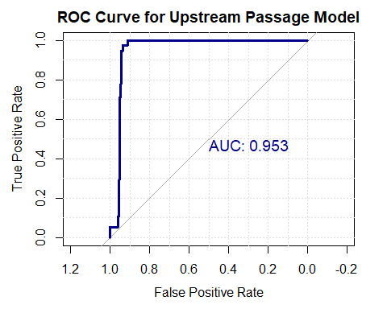
# The curve being in the top left corner along with a high AUC shows strong ability of the model to discriminate between upstream passage and non-passage events.
# This indicates that the Random Forest model performs well in ranking risk of movement, even though classification performance depends on threshold selection
library(ggplot2)
ggplot(as.data.frame(table(Predicted=predict(rf_M,newdata=test_data),Actual=test_data$Up.passage)),
aes(x=Actual,y=Predicted,fill=Freq))+geom_tile(color="black")+geom_text(aes(label=Freq),size=6)+
scale_fill_gradient(low="#A6CEE3",high="#1F78B4")+labs(title="Confusion Matrix: Random Forest Passage Model",x="Actual Upstream Passage",
y="Predicted Upstream Passage")+theme_minimal(base_size=14)
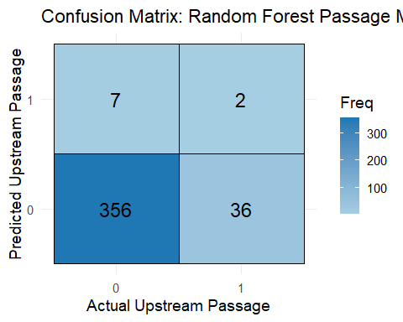
# This shows model is very good at predicting when passage doesn't occur.
# Does sometimes predict passage when it doesn't happen. Common for rare-event data sets.
# 792 True Negatives, 46 True Positives, 36 False Positives, 25 False Negatives
library(ggplot2)
test_probs <- predict(rf_M, newdata = test_data, type = "prob")
test_pred_class <- ifelse(test_probs[,2] > 0.2, 1, 0)
ggplot(as.data.frame(table(Predicted = test_pred_class,
Actual = test_data$Up.passage)),
aes(x = Actual, y = Predicted, fill = Freq)) +
geom_tile(color = "black") +
geom_text(aes(label = Freq), size = 6) +
scale_fill_gradient(low = "#A6CEE3", high = "#1F78B4") +
labs(title = "Confusion Matrix: Random Forest Passage Model (Threshold = 0.2)",
x = "Actual Upstream Passage",
y = "Predicted Upstream Passage") +
theme_minimal(base_size = 14)
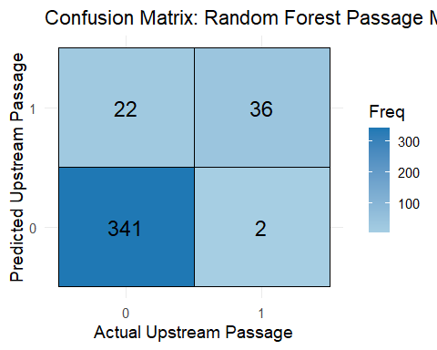
# This shows improved detection of upstream passage events after threshold tuning.
# The model now captures more true positives but introduces additional false positives, which is expected in rare-event ecological prediction problems.
importance_df <- as.data.frame(importance(rf_M))
importance_df$Variable <- rownames(importance_df)
top_vars <- head(importance_df[order(-importance_df$MeanDecreaseGini),"Variable"],5)
top_vars
## [1] "log_Weight" "Length" "Season" "Week" "Barge.Tot.n"
test_data$pred_prob <- test_probs[,2]
aggregate(pred_prob ~ Season, data = test_data, mean)
## Season pred_prob
## 1 FAL 0.006089888
## 2 SPR 0.150764706
## 3 SUM 0.260119403
## 4 WINT 0.001876777
season_df <- aggregate(pred_prob ~ Season, data = test_data, mean)
ggplot(season_df, aes(x = Season, y = pred_prob)) +
geom_bar(stat = "identity") +
labs(title = "Average Predicted Probability by Season",
x = "Season",
y = "Mean Predicted Probability") +
theme_minimal(base_size = 14)
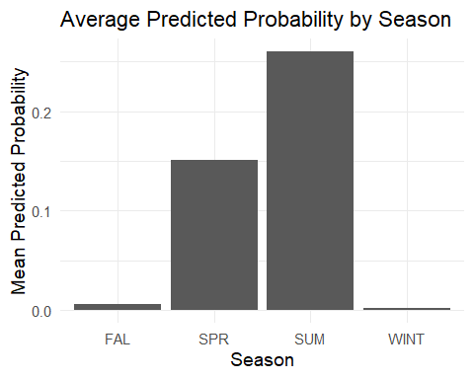
aggregate(pred_prob ~ Species, data = test_data, mean)
## Species pred_prob
## 1 BHCP 0.21802703
## 2 GSCP 0.02698785
## 3 SVCP 0.00865000
species_df <- aggregate(pred_prob ~ Species, data = test_data, mean)
ggplot(species_df, aes(x = Species, y = pred_prob)) +
geom_bar(stat = "identity") +
labs(title = "Average Predicted Probability by Species",
x = "Species",
y = "Mean Predicted Probability") +
theme_minimal(base_size = 14)
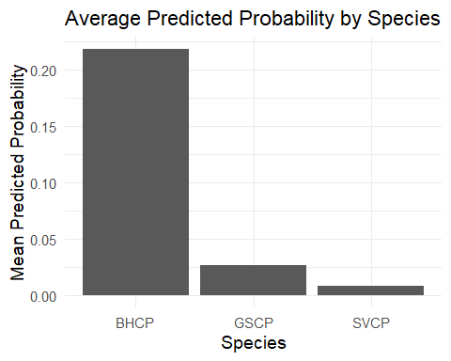
### GRADIENT BOOSTING MODEL (XGBOOST) FOR INVASIVE CARP PASSAGE
library(xgboost)
## Warning: package 'xgboost' was built under R version 4.4.3
library(caret)
## Warning: package 'caret' was built under R version 4.4.3
## Loading required package: lattice
##
## Attaching package: 'caret'
##
## The following object is masked from 'package:purrr':
##
## lift
library(pROC)
library(ggplot2)
##Data prep
#Using the main_clean data set from earlier processing
xg_data<-main_clean
#Ensuring categorical variables are factors
char_cols<-sapply(xg_data, is.character)
xg_data[char_cols]<-lapply(xg_data[char_cols], as.factor)
#Convert response variable to numeric 0/1 for XGBoost
xg_data$Up.passage<-as.numeric(as.character(xg_data$Up.passage))
#Removing irrelevant variables
remove<-c("UpPass.2017","UpPass.2018","Down.passage","Weight","START_DATETIME","END_DATETIME","DeployDate","AGENCY", "Deploy.loc")
#Filter for specific carp species of interest
xgcarp_data<-xg_data[xg_data$Species %in% c("SVCP", "BHCP", "GSCP"), ]
# Actively drop the leakage columns from the data frame
xgcarp_data<-xgcarp_data[, !(names(xgcarp_data) %in% remove)]
xgcarp_data<-droplevels(xgcarp_data)
#Split by TransmitterID so the model doesn't memorize specific fish
id<-xgcarp_data$TRANSMITTERID
#Create the model matrix (removing ID and the intercept)
X<-model.matrix(Up.passage ~ . - TRANSMITTERID - 1,data=xgcarp_data)
y<-xgcarp_data$Up.passage
#Splitting the data
set.seed(123)
unique_fish<-unique(id)
train_fish<-sample(unique_fish, size=0.7 * length(unique_fish))
train_index<-id %in% train_fish
X_train<-X[train_index, ]
X_test<-X[!train_index, ]
y_train<-y[train_index]
y_test<-y[!train_index]
##Handling class imbalance
#Calculate weight for the positive class to handle rare passage events
#Because passage is rare, calculate a weight to tell the model to pay extra attention to movers
neg<-sum(y_train==0)
pos<-sum(y_train==1)
scale_pos_weight<-neg/pos
# Convert data into XGBoost's high-performance DMatrix format
dtrain<-xgb.DMatrix(data=X_train,label=y_train)
dtest<-xgb.DMatrix(data=X_test,label=y_test)
##Training
params<-list(objective="binary:logistic",eval_metric="aucpr",# Focus on Precision-Recall for imbalanced data
max_depth=4,eta=0.05,subsample=0.8,colsample_bytree=0.8,scale_pos_weight=scale_pos_weight)
# Max Depth 4 limits tree depth to 4, eta.05 menas the learning rate is slower, subsample 0.8 means 80% of data per tree is used
#Training the XGBoost model
model<-xgb.train(params=params,data=dtrain,nrounds=200,verbose=0)
#Convert probabilities to classes based on custom threshold of .25 since it is less like for a fish to pass upstream
pred_prob<-predict(model, X_test)
pred_class<-ifelse(pred_prob > 0.25, 1, 0)
##Model Eval
#Confusion matrix
conf_mat<-confusionMatrix(factor(pred_class,levels=c(0,1)),factor(y_test,levels=c(0,1)),positive="1")
print(conf_mat)
## Confusion Matrix and Statistics
##
## Reference
## Prediction 0 1
## 0 341 6
## 1 22 32
##
## Accuracy : 0.9302
## 95% CI : (0.9007, 0.9531)
## No Information Rate : 0.9052
## P-Value [Acc > NIR] : 0.048127
##
## Kappa : 0.6576
##
## Mcnemar's Test P-Value : 0.004586
##
## Sensitivity : 0.84211
## Specificity : 0.93939
## Pos Pred Value : 0.59259
## Neg Pred Value : 0.98271
## Prevalence : 0.09476
## Detection Rate : 0.07980
## Detection Prevalence : 0.13466
## Balanced Accuracy : 0.89075
##
## 'Positive' Class : 1
##
cm_table<-as.data.frame(conf_mat$table)
colnames(cm_table)<-c("Predicted", "Actual", "Count")
ggplot(cm_table,aes(x=Actual,y=Predicted,fill=Count))+geom_tile(color="white")+geom_text(aes(label=Count),size=6)+
scale_fill_gradient(low="lemonchiffon",high="darkgoldenrod")+labs(title="Confusion Matrix: XGBoost Carp Passage Model",
x="Actual Class",y="Predicted Class")+theme_minimal(base_size = 14)
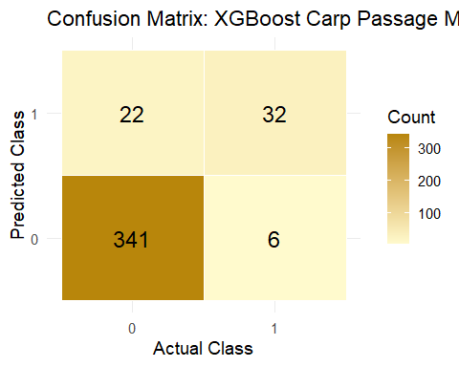
#The model correctly classified about 93% of all cases overall.
#The model correctly identified about 84% of the actual positive cases.
#The model correctly identified about 94% of the actual negative cases.
#When the model predicted a positive, it was correct about 59% of the time.
#When the model predicted a negative, it was correct about 98% of the time.
#Kappa of 0.6576 means the models agreement between predicted labels and actual ground truth labels is very good.
#The model performs well across both classes, averaging about 89% correct classification per class.
# Calculating key performance metrics: Precision, Recall (Sensitivity), and F1-Score
precision<-conf_mat$byClass["Pos Pred Value"]
recall<-conf_mat$byClass["Sensitivity"]
f1<-2*(precision*recall)/(precision+recall)
metrics<-data.frame(Precision=precision,Recall=recall,F1_Score=f1)
print(metrics)
## Precision Recall F1_Score
## Pos Pred Value 0.5925926 0.8421053 0.6956522
##Visuals
#Prep results for plotting
test_results<-xgcarp_data[!train_index, ]
test_results$pred_prob<-pred_prob
test_results$actual<-factor(y_test, levels=c(0,1), labels=c("No Passage", "Upstream"))
#Risk vs Weight (Log Scale)
ggplot(test_results, aes(x=log_Weight,y=pred_prob))+geom_point(aes(color=actual),alpha=0.3)+
geom_smooth(method="loess",color="black") +scale_color_manual(values=c("seashell3", "dodgerblue3"))+
labs(title="Movement Risk vs Fish Weight", x="Log-Weight (g)", y="Predicted Risk Score")+
theme_minimal(base_size = 14)
## `geom_smooth()` using formula = 'y ~ x'
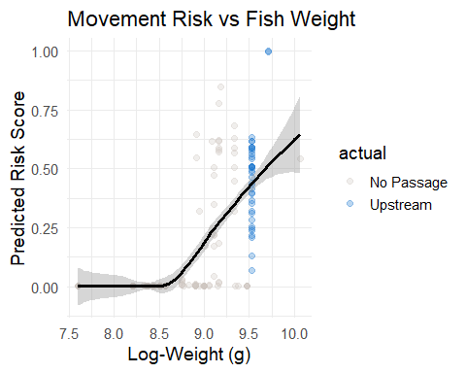
#Risk vs Water Stage
ggplot(test_results,aes(x=Stage.m,y=pred_prob))+geom_point(aes(color=actual),alpha=0.3)+
geom_smooth(method="loess",color="darkseagreen")+scale_color_manual(values=c("steelblue4","dodgerblue"))+
labs(title = "Movement Risk vs Water Stage", x = "Stage (m)", y = "Predicted Risk Score") +
theme_minimal(base_size = 14)
## `geom_smooth()` using formula = 'y ~ x'
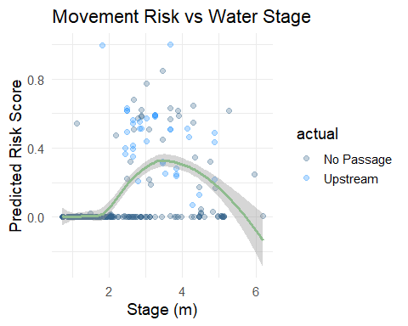
#Seasonal Risk Trends by Temperature
ggplot(test_results, aes(x=Temp,y=pred_prob,color=Season))+geom_smooth(se=FALSE,size=1.5,span=1.0)+
labs(title="Seasonal Thermal Risk Profiles",x ="Water Temperature (C)",y="Predicted Risk")+theme_minimal(base_size=14)
## Warning: Using `size` aesthetic for lines was deprecated in ggplot2 3.4.0.
## ℹ Please use `linewidth` instead.
## This warning is displayed once per session.
## Call `lifecycle::last_lifecycle_warnings()` to see where this warning was
## generated.
## `geom_smooth()` using method = 'loess' and formula = 'y ~ x'
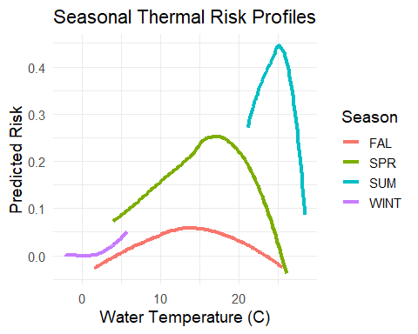
#ROC Curve
ggroc(roc_obj,colour="dodgerblue3", size=1.2)+geom_abline(slope=1,intercept=1,linetype="dashed",color="grey")+
labs(title=paste("XGBoost ROC Curve (AUC =",round(auc(roc_obj), 3), ")"))+
theme_minimal(base_size=14)
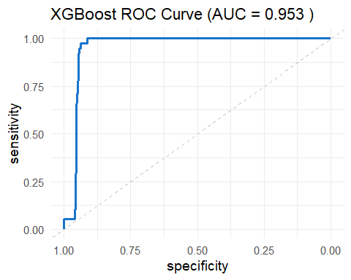
#FEATURE IMPORTANCE
# Extract and plot the most influential biological and environmental predictors
importance<-xgb.importance(feature_names = colnames(X_train),model=model)
xgb.plot.importance(importance[1:min(10, nrow(importance)),],col="dodgerblue3",main="Top Predictors of Upstream Movement")
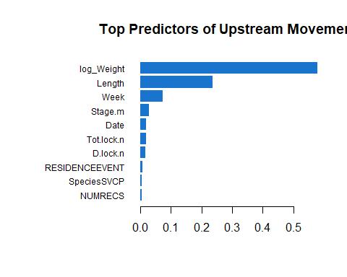
### K Nearest Neighbors Model
# Train a KNN model using cross-validation to find the best value of k (number of neighbors)
# Data is standardized (centered and scaled) because KNN is distance-based and sensitive to scale
knn_model<-train(X_train,factor(y_train),method = "knn",preProcess = c("center", "scale"),
tuneLength = 10, # Tests different numbers of neighbors
trControl = trainControl(method = "cv")) # Uses k-fold cross-validation for model tuning
## Predictions
# Get probabilities for the test set
knn_probs<-predict(knn_model,newdata = X_test,type = "prob")[,"1"]
# Convert probabilities into class predictions using a custom threshold (0.25 instead of default 0.5)
# Lower threshold makes the model more sensitive to detecting positives
knn_preds<-ifelse(knn_probs> 0.25, 1, 0)
## Evaluation
#Build a confusion matrix comparing predicted vs actual values
conf_mat_knn <- confusionMatrix(factor(knn_preds, levels = c(0,1)),factor(y_test, levels = c(0,1)),positive = "1")
print(conf_mat_knn) # Print performance metrics (accuracy, sensitivity, specificity, etc.)
## Confusion Matrix and Statistics
##
## Reference
## Prediction 0 1
## 0 347 6
## 1 16 32
##
## Accuracy : 0.9451
## 95% CI : (0.9181, 0.9653)
## No Information Rate : 0.9052
## P-Value [Acc > NIR] : 0.002438
##
## Kappa : 0.7139
##
## Mcnemar's Test P-Value : 0.055009
##
## Sensitivity : 0.84211
## Specificity : 0.95592
## Pos Pred Value : 0.66667
## Neg Pred Value : 0.98300
## Prevalence : 0.09476
## Detection Rate : 0.07980
## Detection Prevalence : 0.11970
## Balanced Accuracy : 0.89901
##
## 'Positive' Class : 1
##
# 347 True Negatives the model correctly predicted 0 (no event) 347 times.
# 32 True Positives the model correctly predicted 1 (event happened) 32 times.
# 6 False Negatives the model missed 6 real events (it predicted 0 when it was actually 1).
# 16 False Positives the model incorrectly predicted 1 when it was actually 0.
#The model correctly predicts the outcome about 94.5% of the time overall.
#Kappa of 0.7139 means the model shows good agreement between predictions and actual values beyond chance.
#The model correctly identifies about 84% of actual positive events (1s).
#The model correctly identifies about 95.6% of actual negative cases (0s).
# Create data frame from your KNN matrix results
cm_data<-as.data.frame(conf_mat_knn$table)
# Create heatmap of confusion matrix results
ggplot(cm_data, aes(x=Reference,y =Prediction,fill=Freq)) +
geom_tile(color="white")+geom_text(aes(label=Freq),size=10,color="white") +
scale_fill_gradient(low="steelblue",high = "coral1") +scale_x_discrete(labels = c("Actual: No", "Actual: Yes")) +
scale_y_discrete(labels=c("Pred: No", "Pred: Yes"))+labs(title = "KNN Predictive Accuracy",fill ="Fish Count")+
theme_minimal(base_size=16) +theme(legend.position="none",panel.grid.major=element_blank())
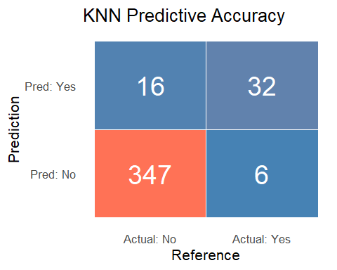
# Create ROC object using predicted probabilities
roc_knn<-roc(y_test, knn_probs)
## Setting levels: control = 0, case = 1
## Setting direction: controls < cases
# Plot ROC curve
plot(roc_knn,col= "blue",lwd=3,main="ROC Curve - KNN Model")
# Add AUC value to plot
auc_value<-auc(roc_knn)
text(0.6, 0.2, paste("AUC =", round(auc_value, 3)))
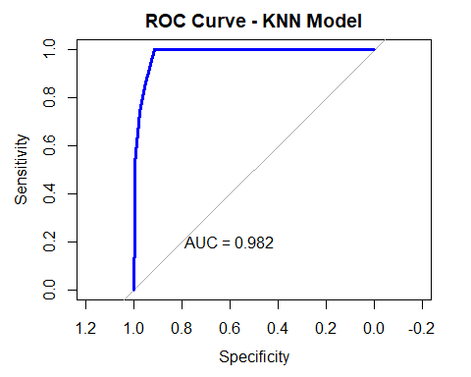
# Create dataset
plot_data <- data.frame(Variable = X_test[, "Stage.m"], Prob = knn_probs)
# Plot
ggplot(plot_data, aes(x = Variable, y = Prob)) +
geom_point(alpha = 0.4) +
geom_smooth(method = "loess", color = "coral1", size = 1.5, se = TRUE) +
geom_hline(yintercept = 0.25, linetype = "dashed", color = "black") +
labs(title = "Risk Curve: Fish Passage Probability",
subtitle = "How probability of passage changes with river height",
x = "River Stage (m)",y = "Predicted Probability") +theme_minimal()
## `geom_smooth()` using formula = 'y ~ x'
